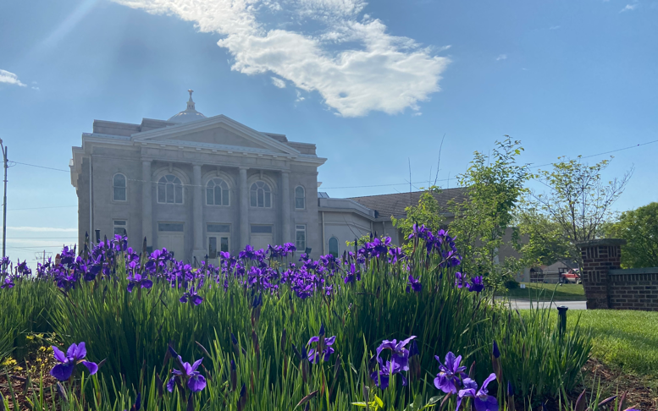
Volume 27, Issue #4
May 2023

Our Mission is: 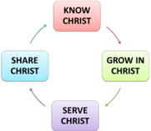to share the good news of the life, death and resurrection of Jesus Christ and to exemplify the love of God by knowing Christ, growing in Christ, serving Christ and sharing Christ.”

The
Connexion
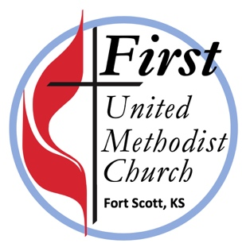

On the Christian Journey…
With Pas

POTLUCK LUNCHEON June 4th

Join us for food and
fellowship after worship.
Bring your favorites
entrée, side dish or
dessert to share!

On the Christian Journey…
with Pastor Christopher

I feel like I called in a pinch hitter who then hit a home run! In realizing I needed a Sunday off and time with family, and then inviting Mary Brooks to speak, I found a missing piece of the series on Spiritual Gifts I’d been developing. She shared insights she gained from scripture and author Max Lucado’s book “Cure for the Common Life” about finding our “Sweet Spot.”
One example was that place where the ball meets the fat of the bat. More importantly, it is that place where our unique spiritual gifts are used in our daily life to glorify God. Mary made a great contribution to our series on our Spiritual Gifts and how we are equipped for every good work. I was reminded that we do not do this work alone, but together with others in the body of Christ! Mary being here enabled me to take the first Sunday off that I since last summer. It’s amazing how quickly the year has gone with events and gatherings largely back to normal. Spring weather and rescheduling created an opportunity to see both of our sons and our new daughter in law coach games on one trip. Amazingly we were able to watch 7 games and our kid’s teams won all 7 of them! Home run!

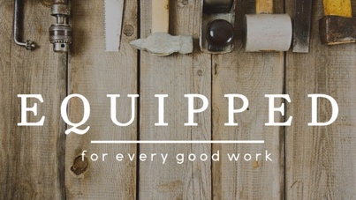
Pentecost is May 28 – Wear Red to Worship!
A day to celebrate the coming of the Holy Spirit and to claim our gifts and call as the body of Christ, the church! Between now and then, you are encouraged to explore your own unique combination of gifts. As we continue through our sermon series “Equipped for Every Good Work,” you are invited to consider each of the following approaches to learning more about your gifts:

- Pray: Ask God to reveal your spiritual gifts. There are many ways to pray – here is one resource you may find helpful https://www.umc.org/en/content/the-mysterious-connectional-act-of-prayer
- Read these basic definitions: https://www.umc.org/en/content/exploring-your-spiritual-gifts
- Ask: Speak with spiritually mature people who know you well and ask them what spiritual gifts they see in you. Often what others see in us will surprise us!
- Serve: Think about serving opportunities you have enjoyed, noting where you feel most energized and effective. Soon you will come to see where you are most effective, what your spiritual gifts are, and where your “sweet spot” is. Another way to think about it is “that place where your deepest joy meets the world’s deepest needs.” ~Fredrick Buechner
- Assess: Take an online spiritual gifts assessment to identify your gifts. Here is one hosted by United Methodist Discipleship Ministries: https://www.umcdiscipleship.org/spiritual-gifts-inventory/en

That assessment will take approximately 20 minutes to complete. Go with your first response, not overthinking it. Keep in mind that a self-assessment has its inherent shortcomings as it will only point to your possible gifts. The best discovery method is to serve and have others speak into and affirm the spiritual gifts they see in you. Once you receive your results, discuss them with others to further explore your unique gifts.
301 S National, Fort Scott, KS 66701 Web Site: www.firstumcfsks.org Email: secretary@firstumcfsks.org
Office Phone: (620) 223-1950 Facebook/Instagram: firstumcfsks pastor@firstumcfsks.org
Using IRA Distributions to Enhance Your Charitable Giving While Reducing Taxes!
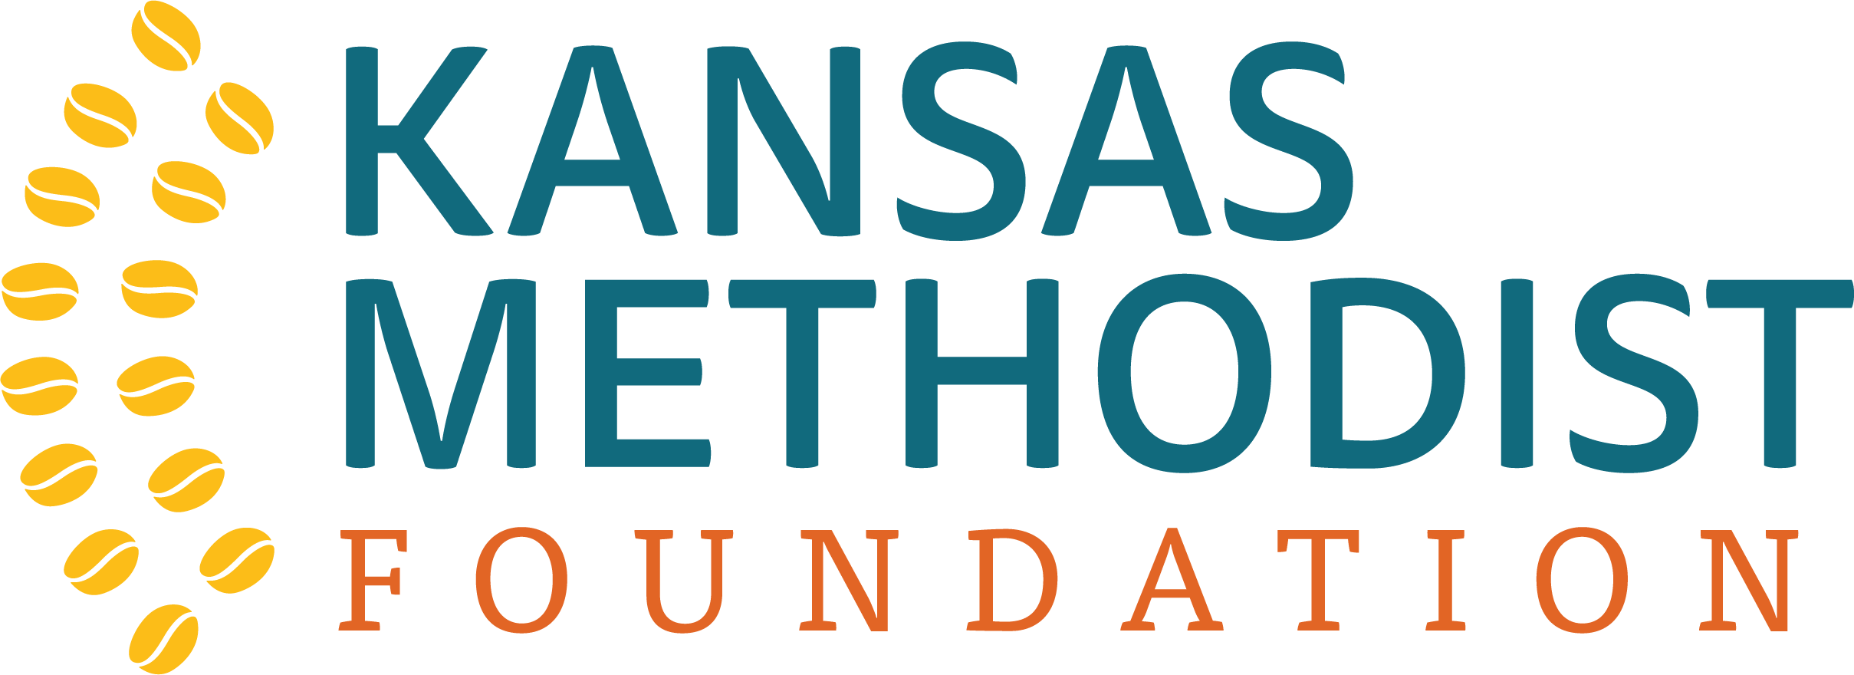
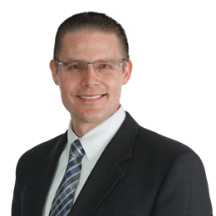
A few weeks ago we had Rev. Dr. Dustin Petz here sharing about how our giving can change lives. At the afternoon session he shared a number of tips about giving more efficiently. One key insight was that, for those who have Traditional IRA’s (Individual Retirement Accounts) and who are 70½ years or older, it is required to take a distribution from those funds each year. If you take them as income, you pay taxes on that income. However, if you direct your financial instittuion to send the disbursement to an 501c3 charitable organziation (such as your favorite United Methodist Church) you do NOT incur taxes on those funds. You could increase your charitable giving to the church and other causes you support without changing your budget! You are encouraged to consult with your financial advisors about what strategies are best for you.

One person at the presentation realized they had implemented such a direct donation from their IRA for a college program they support, but hadn’t thought to do so for the amount they give to the church! If you would like additional information, Dustin and the team at the Kansas Methodist Foundation are available to help answer your questions as well as help you navigate things like establishing trusts and other strategies to help you accomplish your goals and leave a lasting legacy that changes lives.
You can reach them at info@kansasmethodistfoundation.org or (620) 664-9623.

UPCOMING CHURCH COMMITTEE MEETINGS
Monday, May 8th – 6pm HOCROC (Hospitality, Outreach and Community Relations) – Library
Tuesday, May 9th – 7pm Trustees – Library
Wednesday, May 17th – 6pm – Memorials and Gifts – Library, 7pm Administrative Board – Library

Faith Builders in May

THANK YOU, BARBARA!
Barbara Gibson recently stepped back after many years of serving as our Preschool Sunday School teacher. Over the years she has contributed her love of Christ to the lives of many of our children and grandchildren. Her last students, the Bishop boys, have now made the move upstairs to Sunday Morning Explorers (led by Cindy Foxx and Charlene Sipe). Barbara’s husband Keith is increasingly reliant on her presence and care, and we ask the congregation to hold them both in prayer.

UPDATE FROM THE WEDNESDAY READING GROUP by Dorothy Kivett
The reading group will meet May 10th.

We will not meet May 17th but will have a pie party at Dorothy Kivett’s home on May 24th
at 1:30pm. This will conclude the Fall/Winter session. Thanks to all who have attended.

– You are invited! 9:30am Sundays

In May, we will be continuing our study and discussion of an Adam Hamilton DVD study of “The Lord’s Prayer.” This six-part study, an in-depth look at the prayer Jesus taught us, will close May 21.
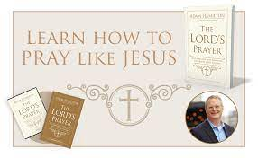

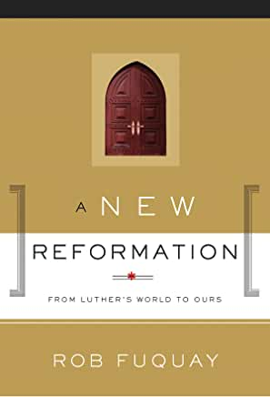
On May 28 we will begin discussing a six-part DVD program on “A New Reformation,” by Rob Fuqua. This is a refreshing look at Martin Luther and the Reformation as a focus on the importance of our stories as part of God’s bigger story. We invite you to become part of our group as we continue our walk with Christ. Please join us in fellowship and discussion.
~Ron Wood

Sunday, June 11th - Special Combined Worship AT 1st Presbyterian – 3rd and Crawford - 10:30am

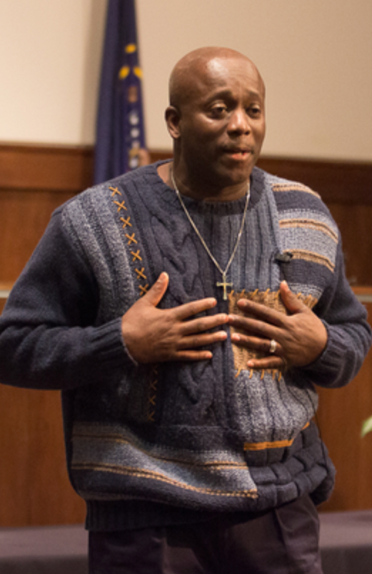
While Pastor Christopher is away with the Appalachian Service Project mission trip, Diana Endicott from 1st Presbyterian has arranged for a special guest speaker. 1st Presbyterian will host, and we will join them at their 10:30am service. Pastor Darryl Burton graduated from Saint Paul School of Theology in 2016 and serves on the staff of the United Methodist Church of the Resurrection in Kansas City, one of the largest United Methodist Churches in the US. Prior to that, Pastor Burton served 24 years in prison for a crime he did not commit. He now leads the “Miracle of Innocence” program, supporting others who have experienced injustice. Here is more of his story:

In 1984, a drug dealer was shot to death at a gas station in St. Louis, Missouri. The man who shot him was a lightskinned African American male, 5’5” in height. Police looked for suspects and even though Darryl Burton was dark skinned and 5’10” in height, he was summoned to a police lineup. Two men came forward identifying Darryl as the murderer. Both were awaiting trial but were given a lighter sentence if they testified that Burton was guilty. Burton was assigned a public defender who spent only one hour with him before his trial and the jury convicted him in less than an hour. Darryl found himself being sentenced to life in prison without parole. He was assigned to the Missouri State Penitentiary, one of the most violent prisons in the U.S.

Darryl remembers, “When I heard the jurors say guilty, I felt shock and disbelief. I just didn’t think, in America, an innocent man could be sent to prison, especially capital murder” explained Burton. He clearly remembers a huge banner that hung at the entrance of the penitentiary that said “Welcome to the Missouri State Pen. Leave all your hopes, family, and dreams behind.” “When I saw that banner, it deeply affected me and I lost all hope. I hated the place, the system, and anyone that had anything to do with it. It was hell on earth – filled with violence, evil, and hate.”

Darryl remained in prison from 1984-2009 and spent many of those days in the prison law library, dedicated to proving his innocence. He wrote over 600 letters to members of the government, nonprofit organizations, even Oprah Winfrey to plead his case. However, it was not until he allowed Christ into his life that he began to experience a change. Darryl discovered that anger and hate can be another prison, and that Jesus said we must love our enemies, pray for them, and forgive them. “Until I read that truth in Luke 23:34, I didn’t think that was possible,“ he said. Ten years prior to Darryl’s exoneration, he felt emotionally and spiritually freed. “God had to work something out of me (bitterness and hatred), in order to work something into me (love and grace), in order to do His work through me.”

After learning of a confession from a witness who admitted in 1985, “You have the wrong man, he’s too dark,” Darryl worked with Centurion Ministries to have his wrongful conviction overturned. Darryl often recalls a letter that he wrote to Jesus while imprisoned. It said “Jesus, if you’re real and help me get out of this place, not only will I serve you, but I’ll tell the world about you.” Darryl now shares his nightmare story of adversity to help others and bring glory to the name of Jesus Christ. Since 2009, he has spoken about forgiveness, redemption, and hope at churches and conferences around the globe. Seven years after his exoneration, he never takes one day for granted. “I’m doing things today that can only be by the grace and mercy of God,” Burton says. “I have come to embrace my walk of faith. I pray to be a humble servant in my ministry.” First United Methodist and 1st Presbyterian are delighted to welcome Darryl to Fort Scott!

Invite your friends to experience Darryl’s witness firsthand during this special combined worship service AT 1st Presbyterian – 3rd and Crawford. 10:30am, Sunday, June 11th

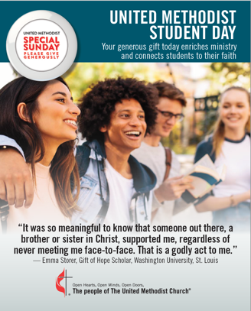
Upcoming Denominational Special Offerings

United Methodist Student Day May 7th, 2023
The United Methodist Student Day offering provides for over 70 scholarships available for United Methodist students to further their education and enrich the life of the Church. Scholarships are administered by the General Board of Higher Education and Ministry and one hundred percent of the offering received goes to this scholarship fund.
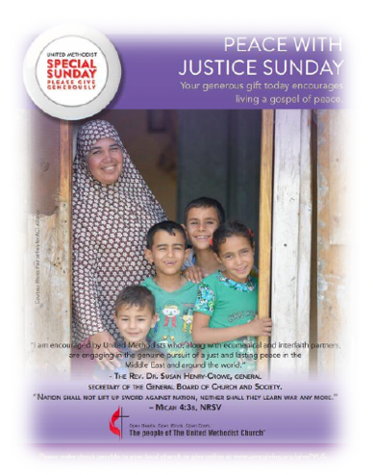
Peace with Justice Sunday – June 4, 2023
Peace with Justice Sunday is the first Sunday after Pentecost. The General Board of Church and Society has a vision to promote justice, by advocating public policies that protect the rights of all people. This offering supports the fostering of a better world by educating leaders and change-makers to become grassroots activists and global advocates who challenge systems of inequality. It also supports the connection of networks with ecumenical communities to advance peace and justice. Fifty percent provides grants to local churches, districts, conferences, and other affiliated organizations that advocate for peace with justice while the other 50% remains in our annual conference to develop local peace with justice ministries and support a peace with justice coordinator.
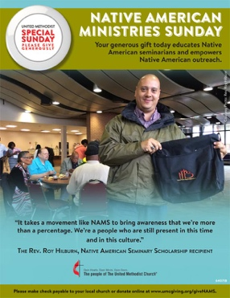
Native American Ministries Sunday – July 23rd
This offering supports the development and strengthening of Native American ministries in the annual conferences, Native American rural, urban, reservation ministries, and communities relating to the General Board of Global Ministries. This offering provides scholarships for Native Americans attending United Methodist schools of theology and it is distributed by the General Board of Higher Education and Ministries and The General Board of Global Ministries with 50% remaining in the annual conference for the Committee on Native American Ministries (CONAM) to administer.

A Community Event You Wont’ Want to Miss!

Pastor Christopher moved our celebration of Native American Ministries to July to connect it with a special event here in Fort Scott!

The Friends of Fort Scott National Historic Site in partnership with the National Park Service invite you to a special performance of Wahzhazhe: An Osage Ballet. There are three performances:
July 21 @ 7:30 pm, and July 22 at 3 pm and 7:30 pm at the Danny and Willa Ellis Family Arts Center at FSCC. For tickets, scan the QR code or visit: https://friendsoffsnhs.ticketspice.com/wahzhazhe.

Wahzhazhe brings to life the rich history of the Osage Nation in a stunningly beautiful stage performance using traditional drumming, costumes, and contemporary dance.

This professional dance performance has been performed at the Smithsonian Museum of the American Indian in Washington D.C. and during Pope Francis' visit to the Philadelphia Festival of Families in 2015.
May Birthdays: 2 Emily Allshouse, carol Newcomer, 3- Teresa Gregory, 4-Amari Berry, Tom Braker, 7-Raymond Minor, 8-Shyann Blanz, Terri Heiser, Garrett Tatro, 9-Blair Croan, 11-Abby Altic, 12- Evan Tatro. 13-Beckett Felt, 14- Joyce Allen, Darrick Green, 15-Dakota Hazelbaker, Keatyn Hunziker, 17-Robin Eshelman, Jennifer Engle, 21- Karleigh Arndt, Ron Snyder, Ron Wood, 22- Christopher Eshelman, 23-Toby Denning, Troy Post, Haley Kruse, 25- Deb Anderson, 26- Barbara Schoonover.

May Anniversaries: 3-Willian and Kristin Bishop, 7-Rick and Chris Comstock, 9-Lauren and Chad Ammons, 21-Susan and Jim Regan, 23-Janet and Reggie Fancher, 28-Cindy and Randall Hiatt.

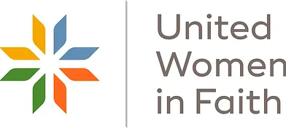
United Women in Faith (UWF) News
United Women in Faith will hold their next meeting June 15, 2023 (please note a change in date) at 1:30 p.m. in the church parlor.
The guest speaker will be Sarah Poteat of Care Portal. She will share information regarding the program and how it helps children in our area. Please save the date and plan to join us in learning about Care Portal. As Women in Faith, we also want to be Women in Action.

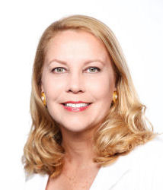
SUMMER VOLUNTEER STAFF MEMBER - INTRODUCING LINDA MCGEE, M.A.
This article is largely a repeat from April’ s newsletter. Linda will arrive next week and be with us into early August. She will use the former Preschool classroom this summer as a temporary office space and meet with people in the Parlor as needed. I am thrilled to work with Linda this summer and am confident she will be a blessing to First UMC and we to her. This really feels like the Spirit working among us!– Pastor Christopher

After a career in corporate risk management, Linda felt a calling to become a therapist and she is currently a licensed marriage and family therapist with an established practice in Florida. During the pandemic, she started an accredited Ph.D. in Counseling and Psychological Studies with Regent University in Virginia. She is nearly finished with that, with plans to graduate in Summer 2024. She also happens to own and spend summers on her family’s historic farm about 25 minutes northeast of Fort Scott, which happily leads her to working with us this summer to complete her doctoral program’s supervised field experience requirements.

Linda and Pastor Christopher have visited several times and he has formally agreed to serve as her field experience supervisor as she helps First UMC with all sorts of projects. Linda will volunteer between 15 and 20 hours a week in May, June, and July. We note she is not (yet) licensed as a therapist in Missouri and Kansas as Florida does not have a reciprocity agreement here, but she will be able to appropriately offer short-term “Christian counseling” drawing on her strengths and experience, if you would find that helpful.

She writes: “Through my own 60-ish years of life experience, I have helped clients work through difficult issues, many of which I have also faced, including grief, anxiety, and life-changing transitions (such as retirement, divorce, relocation, and illness). Here is the summary of our proposal to her program supervisor.
“Overall, provide competent services to support the Pastoral and Leadership Teams at First United Methodist Church of Fort Scott, Kansas, especially through development and delivery of community outreach efforts aligned with the First UMC Church mission. Maintain regular office hours to support congregational pastoral counseling needs, especially when Pastor Eshelman is out of town. Volunteer with Feeding Families weekly meal distribution at the church. Support other church activities as requested by Pastor Eshelman that support the work of the Church and the goals of the Field Experience. A personal goal for me will be to understand whether my retirement career might include a part-time role in the Church or with Shepherd's Centers, and where my strengths and abilities might fit organizationally to contribute to the work of the Church.”
VACATION BIBLE SCHOOL VOLUNTEERS NEEDED!

We have again been invited to participate in a community Vacation Bible School with our friends at First Presbyterian. It will be in the evenings, 5:30-8pm Monday, June 26th through Friday, June 30th.

We are planning to again do a joint VBS celebration Sunday, which would (tentatively) be held here at First UMC on Sunday, July 2nd!
June 26 – 30th 5:30 – 8pm. AT 1st Presbyterian, 3rd and Crawford.

We will need lots of volunteers, food donations and other help to make this a successful week. You can help by donating food for dinner or snacks (final list of requested items will be out in June), helping to lead a group, staffing stations for the groups to visit (music, skits, experiments, reading stories, etc.), helping to decorate, serving the meal or snacks. Denise Needham from 1st Presbyterian is the coordinator this year and can answer any specific questions you have.

Please sign up to volunteer so we can work on finalizing details and serve as many children as possible this summer! You can return this form to either church office or email Zandra at secretary@firstumcfsks.org and we’ll pass the info along. If you know a child who would like to attend, you can get a VBS participant registration form from either church office (or back table in our sanctuary and near entrances).

FIRST PRESBYTERIAN VBS VOLUNTEER INTEREST FORM
PLEASE RETURN BY JUNE 18, 2023
Dates June 26th – 30th, 5:30pm to 8:00pm

Name:_____________________________________________________________________

Address:___________________________________________________________________

Phone (H/C) _______________________________ email: ____________________________

Please indicate any areas of interest:

_____ Group Leader Station Leader / Helper

_____ Meals ____Crafts

_____ Decorating ____Music

____Snack

____Storytime

____Games

_____ I plan to donate food or snacks once the list is published

Other: _______________________________________________________________
Labyrinth Dedication
Sunday May 28th at 11:45am

The stone borders for the Labyrinth we have built in cooperation with 1st Presbyterian are now complete and it is time to dedicate the space! After worship on the 28th, join Pastor Christopher at 3rd and Crawford for a brief ceremony. Come see the sign and benches added using our Healthy Congregation grant funds and be a part of celebrating this new spiritual resource for Fort Scott.

It is laid out where the former Whiteside IGA #2 stood. A place where people once found nourishment for their bodies has been rebirthed as a place of nourishment for the mind and spirit. Our path is framed by debris from the demolition of the building, along with stones gathered from nearby fields. From brokenness and scattering comes a path of wholeness and unity.

A walking labyrinth is a single path to a center. In walking a labyrinth, you literally “center yourself.” Simply enter facing east and follow the path between the stones until you reach the center. Unlike a maze, there are no dead ends or wrong turns.

Upcoming
KMDO Radio
Schedule:
A recording of
our services will
run every other week at 1pm on 103.9 (or occasionally 98.3 if there’s a Chiefs or Royals game conflict).
Our upcoming dates are:
May 7th & 21st
June 4th & 18th
July 2nd, 16th & 30th
August 23th & 27th
September 10th & 24th
October 8th & 22nd

Tell a Friend!

If you change
phone numbers, addresses or email –
please notify the Church Office!

Please help us keep in touch by updating your records frequently – we are still missing lots of cell phone
numbers, for example.
Do we have yours?

If you are getting emails from us at an address you don’t want them - please reply with “Remove from List” and we will do so immediately.

If you aren’t getting weekly updates, but would like to - email Zandra in the office at secretary@firstumcfsks.org and ask to be added to our distribution list. Thank you!

THANK YOU! Appalachian Service Project
Mission Trip Fundraising Goal EXCEEDED!

Your generosity and support of this project has exceeded our goal for 2023. Gifts not used this year will be held as seed money for future trips. We look forward to taking our group of 11 (9 from here and 2 from Fulton who pay their own way) to Booneville, KY to make homes warmer, safer, and drier for their families. The area we are going was heavily affected by the flooding last year. Please be in prayer for those going, those served, and give thanks for all who make the trip possible!
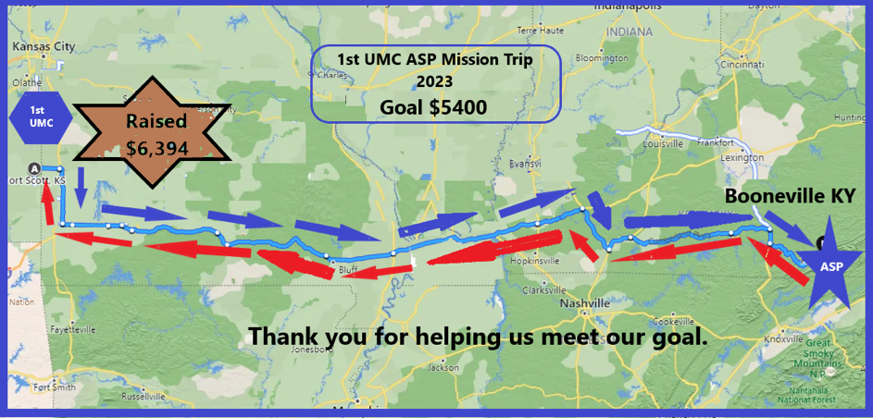

.

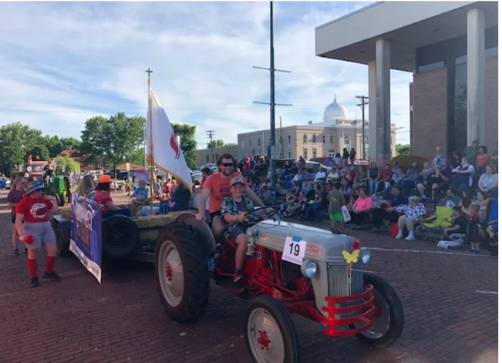
Mark Your Calendar! Invite friends!
Absolute Country, Definitely Gospel
Faith’s Journey!

Branson’s 2021 Gospel Show and Group of the Year
will be in concert here at First UMC on
6pm Friday, July 28th
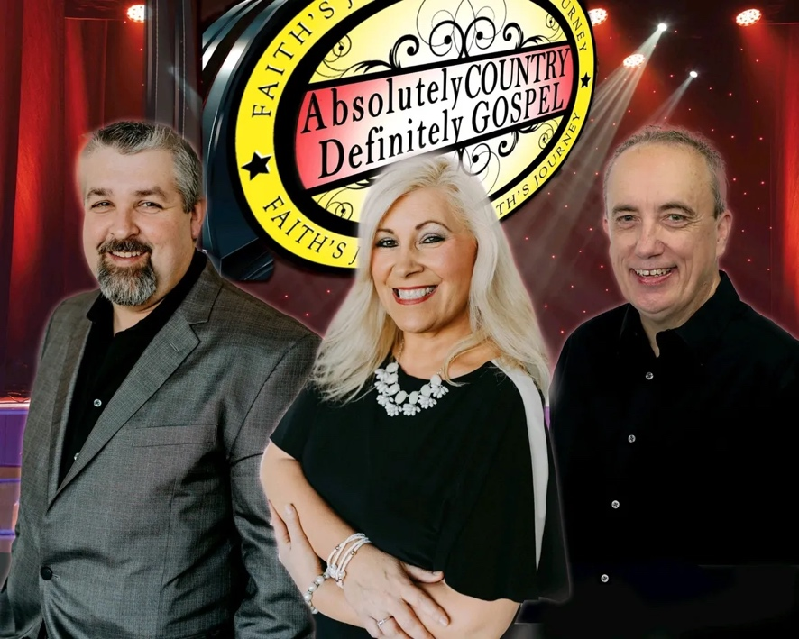
Freewill offering will be collected.

GOOD OL’ DAYS PARADE –
Friday, June 3rd at 6pm

The theme is “Back to the Bricks” for this 42nd annual Fort Scott tradition. Anybody have a good idea for how to decorate at float for that theme? Let us know! And then plan to be a part of our float entry in the parade. Ride along or walk to distribute candy and red “Pentecost” Pinwheels with our church logo, address, and website on them. It’s great fun and a great way to connect with the community and show them that the Spirit is moving at First United Methodist Church!

First United Methodist Church
301 S National
Fort Scott, KS 66701-1397

Return Service Requested

Here is your May 2023
Newsletter from:

Visit us online:
www.firstumcfsks.org
Links to Facebook,
YouTube, Instagram

